JOURNAL OF TECHNIQUES

Journal homepage: http://journal.mtu.edu.iq

RESEARCH ARTICLE
Title of the article
First Author¹*, Second Author², Third Author³
¹Affiliation of the first author
²Affiliation of the second author
³Affiliation of the third author
*Corresponding author E-mail:
Article Info. | Abstract
Article history:  Received  Accepted | The manuscript should contain an abstract. The abstract should be self-contained and citation-free and should not exceed 200 words. The abstract should state the purpose, approach, results and conclusions of the work. The author should assume that the reader has some knowledge of the subject but has not read the paper. Thus, the abstract should be intelligible and complete in it-self (no numerical references); it should not cite figures, tables, or sections of the paper. The abstract should be written using third person instead of first person  Publisher: Middle Technical University
This is an open access article under the CC BY 4.0 license (http://creativecommons.org/licenses/by/4.0/)
Keywords: Use about five keyword and separated by semicolon

Introduction
This document can be used as a template for Microsoft Word. Do not submit papers written with other editors than MS Word, it will not be accepted for review. Submit papers with performing a carefully spellcheck and English language grammar check. The style from these instructions will adjust your fonts and line spacing. Please do not change the font sizes or line spacing to squeeze more text into a limited number of pages.
- Page layout
An easy way to comply with the paper formatting requirements is to use this document as a template and simply type your text into it.
Your paper must use a page size corresponding to A4 which is 21cm wide and 29.7cm long. The margins must be set as follows:
Top = 1.5cm
Bottom = 1.5cm
Left =2cm
Right=1.5cm
Your paper must be in ONE column format.

2.1. The paper should have the following structure
2.1.1. Title of the paper
2.1.2. Authors and affiliations

Nomenclature
CPV concentrating photovoltaic | I_{abs} irradiancies on the absorber plane (W/m2)
CPC compound parabolic concentrator | I_{ape} irradiancies on the aperture plane (W/m2)
CR concentration ratio | L Slant height of the reflector (m)
PCM phase change material | w_{n} width of the incident rays with nth reflections
Symbols | η_{B} optical efficiency (%)
A_{abs} area of the absorber plane (m2) | β reflectivity (%)
C_{eff} effective concentration | Ω vertex angle (º)

2.1.3. Abstract
2.1.4. Keywords
2.1.5. Introduction
2.1.6. Main body
2.1.7. Conclusions
2.1.8. References

- Page style
All paragraphs must be justified alignment. With justified alignment.

3.1. Text font of entire document
The entire document should be in Times New Roman. The font sizes to be use are specify in Table 1.

3.2. Title and author details
All title and author details must be in the left side.
Only the first word in a title must be capital and other word should be in small case. Author details must not show any professional title (e.g. Managing Director), any academic title (e.g. Dr.) or any membership of any professional organization (e.g. Senior Member IEEE).
To avoid confusion, do not use the short name and the family name must be write as the last part of each author name (e.g. Fadhil Abdulrazzaq Kareem).
Each affiliation must include, at the very least, the name of the company and the name of the country where the author is based (e.g. Institute of Technology Baghdad, Middle Technical University, Baghdad, Iraq). Email address is compulsory for the corresponding author.

Table 1 Font Specifications for A4 Papers
Font Size | Appearance (in Time New Roman)
 | Regular | Bold
8 | table caption, centered  figure caption, centered  reference item
9 | Author’s affiliation  Paragraph  abstract body
10 |  | author name
18 |  | Paper title

3.3. Figures and tables
Graphs and other numbered figures should appear throughout the text as close to their mention as possible. Figures shouldn’t infringe upon the page borders.
Figures and tables must be centered in the page. Any table or figure that takes up more than 1 column width must be positioned either at the top or at the bottom of the page
Photos must be crystal clear with such resolution to allow fine details visibility. The elements from any photo must be explained using numbers, letters, etc. The text within a figure or photo must have the same style, shape and height as the caption has.
Any table, figure or picture must have a caption (Fig.1, Table1, etc.) followed by a proper description. All similar graphics must be generated using the same software product (Excel, EES, Matlap, Origin, Mathematica, etc.). Importing graphics into the article as images (JPG, BMP, PNG, etc.) should be avoided. All similar electronic schematics, charts, program flow, simulated characteristics, etc. from the article should be generated using the same software product. Importing images from other articles or books it’s totally forbidden unless they are cited.
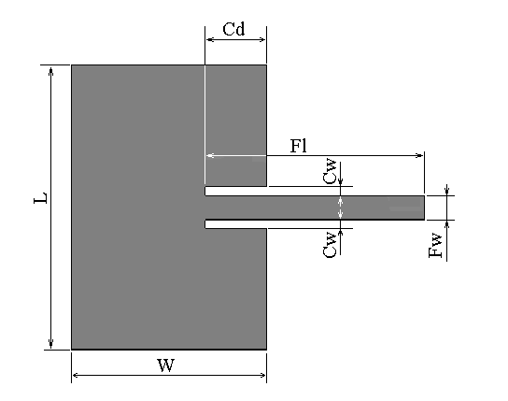
Fig. 1 The text within the figure is Times New Roman, with equivalent height of 10 point, as the caption is. All letters used in the figure are explained in the caption: L = patch length, W = patch width, Cd = cut depth, Cw = cut width, Fl = feed length, Fw = feed width.
3.3.1. Figure captions
Figures must be numbered using Arabic numerals. Figure captions must be in 8 pt Regular font. Captions of a single line (e.g. Fig. 2) must be centered whereas multi-line captions must be justified (e.g. Fig. 1). Captions with figure numbers must be placed after their associated figures, as shown in Fig. 1.
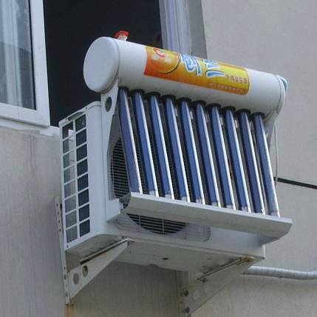
Fig. 2 Solar refrigeration system
3.3.2. Table captions
Tables must be numbered using Arabic numerals. Table captions must be centred and in 8pt Regular font. Captions with table numbers must be placed before their associated tables, as shown in Table 1.

3.4. Equations
Equations should be numbered consecutively throughout the paper. The equation number is enclosed in parentheses and placed flush right, as in (1). Your equation should be typed using the Times New Roman font (please no other font). To create multileveled equations, it may be necessary to treat the equation as a graphic and insert it into the text after your paper is styled.

$\sin{x}+\cos{y=a}$ (1)
$dL=G*d_{w}$ (2)

Use the same symbol into a definition over the entire article. Use correct symbols for physical or technical terms. (Example: ε₀ and not ε0 for permittivity). Do not repeat definitions over the article. Refer to already defined symbols, equations, theorems by using the cross reference number (Example: As pointed in (1) the…).
Acknowledgement
This is a text of acknowledgements. Do not forget people who have assisted you on your work. Do not exaggerate with thanks. If your work has been paid by a Grant, mention the Grant name and number here.

Reference
There are standard reference formats for most types of document. Below are examples of the most common types of document you might want to reference. Each of the following gives a suggested standard format for the reference followed by examples for the different document types.
Book
[Ref number] Author’s initials. Author’s Surname, Book Title, edition (if not first). Place of publication: Publisher, Year.
[1] I.A. Glover and P.M. Grant, Digital Communications, 3rd ed. Harlow: Prentice Hall, 2009.
Book chapter
[Ref number] Author’s initials. Author’s Surname, “Title of chapter in book,” in Book Title, edition (if not first), Editor’s initials. Editor’s Surname, Ed. Place of publication: Publisher, Year, page numbers.
[2] C. W. Li and G. J. Wang, "MEMS manufacturing techniques for tissue scaffolding devices," in Mems for Biomedical Applications, S. Bhansali and A. Vasudev, Eds. Cambridge: Woodhead, 2012, pp. 192-217.
Electronic Book
[Ref number] Author’s initials. Author’s Surname. (Year, Month Day). Book Title (edition) [Type of medium]. Available: URL
[3] W. Zeng, H. Yu, C. Lin. (2013, Dec 19). Multimedia Security Technologies for Digital Rights Management [Online]. Available: http://goo.gl/xQ6doi
Journal article
[Ref number] Author’s initials. Author’s Surname, “Title of article,” Title of journal abbreviated in Italics, vol. number, issue
number, page numbers, Abbreviated Month Year.
[4] F. Yan, Y. Gu, Y. Wang, C. M. Wang, X. Y. Hu, H. X. Peng, et al., "Study on the interaction mechanism between laser and rock during perforation," Optics and Laser Technology, vol. 54, No.1, pp. 303-308, Dec 2013.
E-Journal article
[Ref number] Author’s initials. Author’s Surname. (Year, Month). “Title of article.” Journal Title [type of medium]. volume number, issue number, page numbers if given. Available: URL
[5] M. Semilof. (1996, July). “Driving commerce to the web-corporate intranets and the internet: lines blur”. Communication Week [Online]. vol. 6, issue 19. Available: http://www.techweb.com/se/directlinkcgi?CWK19960715S0005
Conference papers
[Ref number] Author’s initials. Author’s Surname, “Title of paper,” in Name of Conference, Location, Year, pp. xxx.
[6] S. Adachi, T. Horio, T. Suzuki. "Intense vacuum-ultraviolet single-order harmonic pulse by a deep-ultraviolet driving laser," in Conf. Lasers and Electro-Optics, San Jose, CA, 2012, pp.2118-2120.
Reports
[Ref number] Author’s initials. Author’s Surname, “Title of report,” Abbreviated Name of Company., City of Company., State, Report number, year.
[7] P. Diament and W. L. Luptakin, “V-line surface-wave radiation and scanning,” Dept. Elect. Eng., Colombia Univ., New York, Sci Rep. 85, 1991.
Patents
[Ref number] Author’s initials. Author’s Surname, “Title of patent,” Country where patent is registered. Patent number, Abbrev of Month Day Year.
[8] J. P. Wilkinson, “Nonlinear resonant circuit devices,” U.S. Patent 3 624 125, July 16 1990.
Note: Use “issued date” if several dates are given.

Standards
[Reference number] Title of Standard, Standard number, date.
[9] Shunt power capacitors, IEEE standard 18-2012, 2013.
Theses/Dissertations
[Ref number] Author’s initials. Author’s Surname, “Title of thesis,” Designation type, Abbrev. Dept., Abbrev. Univ., City of Univ., State, Year.
[10] J. O. Williams, “Narrow-band analyser,” Ph.D. dissertation, Dept. Elect. Eng., Harvard Univ., Cambridge, MA, 1993.
Datasheets
[Ref number] Author’s initials. Authors Surname, “Title of Datasheet,” Part datasheet, Publication date [Latest revision date].
[11] Texas Instruments, “High speed CMOS logic analog multiplexers/demultiplexers,” 74HC4051 datasheet, Nov. 1997
[Revised Sept. 2002].
Online Documents
[12] M.R. Brooks, “Musical toothbrush with adjustable neck and mirror,” U.S Patent 326189 [Online], May 19 1992. Available: http://goo.gl/VU1WEk
Websites
[Ref number] Author’s initials. Authors Surname. (Year, Month. Day). Title of web page [Online]. Available: URL
[13] BBC News. (2013, Nov. 11). Microwave signals turned into electrical power [Online]. Available: http://www.bbc.co.uk/news/technology-24897584
[14] M. Holland. (2002). Guide to citing internet sources [Online]. Available: http://www.bournemouth.ac.uk/library/using/guide_to_citing_internet_sourc.html

